Student Name: Bahaa Eddin
Student ID: 253UA255MK
Role: Student A (File System Analysis & Monitoring)
Module: Directory Monitoring System
1. Introduction
The objective of this individual component was to design and implement a Python-based module capable of monitoring a specific directory within a Linux environment. The system works by detecting changes to the file system state—specifically File Creation, Deletion, and Modification—and logging these events with detailed metadata. This module serves as the foundational data source for the group's integrated reporting system.
2. System Design and Logic
I utilized a polling-based approach (snapshot comparison) to monitor the directory.
Initialization: The script sets up a monitoring target and initializes a CSV log file with appropriate headers.
- State Capture (Snapshot): The system scans the directory using os.listdir() and extracts metadata for every file found.
Comparison Logic:
Creation: If a file exists in the Current Snapshot but not the Previous Snapshot, it is flagged as "New."
Deletion: If a file existed in the Previous Snapshot but is missing from the Current Snapshot, it is flagged as "Deleted."
Modification: If a file exists in both, the system compares specific attributes (Size, Permissions, and Modification Timestamp). If any differ, it is flagged as "Modified."
Logging: All events are written to a structured CSV file for consumption by the Reporting Module (Student C).
3. Implementation of OS Concepts
The core of this module relies on interacting with the Linux Virtual File System (VFS) and understanding how Linux stores file metadata in Inodes.
3.1. Metadata Extraction (os.stat)
In Linux, file attributes are stored in the inode, separate from the filename. I used the Python os.stat() system call (wrapped in pathlib) to access this inode information.
Permissions: I extracted the st_mode attribute. Since Linux permissions are bitwise, I used stat.S_IMODE to isolate the permission bits and converted them to Octal (e.g., 0o644) to make them human-readable and comparable against changes made by the chmod command.
User and Group IDs: Linux identifies owners by UID (User ID) and GID (Group ID), not names. I utilized the pwd (Password Database) and grp (Group Database) libraries to map the raw integer IDs (e.g., 1000) returned by the file system to the actual user names (e.g., student_a) found in /etc/passwd.
3.2. File Types
The module distinguishes between standard files, directories, and symbolic links. This leverages the Linux file type bitmasks found in st_mode.
4. Python Programming Techniques
The solution is implemented using Object-Oriented Programming (OOP) to ensure modularity.
Class Structure: A DirectoryMonitor class encapsulates the state (the previous_state dictionary) and methods. This ensures the module can be easily imported into the main group script without variable conflicts.
Data Structures: I used Dictionaries (Hash Maps) to store file snapshots. The filename serves as the key, and the value is a dictionary of metadata. This allows for
O
(1)
O(1)
time complexity when checking if a file exists, ensuring the monitor remains efficient even with many files.
Exception Handling: The code includes try-except blocks to handle FileNotFoundError (in case a file is deleted during a scan) and PermissionError (if the script lacks read access to a specific file), ensuring the monitoring process does not crash.
5. Testing and Verification
The module was tested in a Linux terminal environment. The following scenarios were executed to verify functionality:
Scenario 1: File Creation
Command used: touch test_file.txt
Result: The system detected the new file and logged its initial permissions (0o644) and size (0 bytes).
Scenario 2: Modification (Content & Permissions)
Command used: echo "data" > test_file.txt and chmod 777 test_file.txt
Result: The system detected the change in file size and the permission shift from 644 to 777.
Scenario 3: File Deletion
Command used: rm test_file.txt
Result: The system successfully identified the missing file and logged the deletion timestamp.
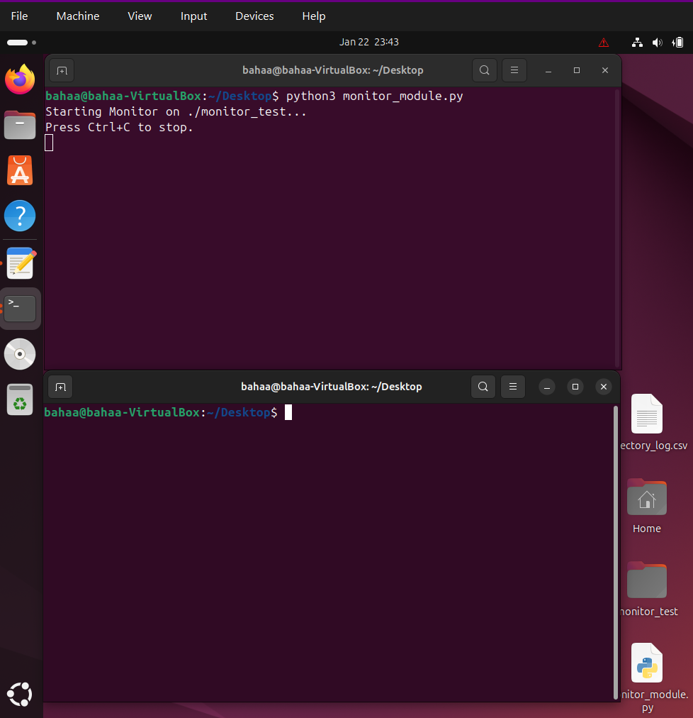
Evidence of Execution

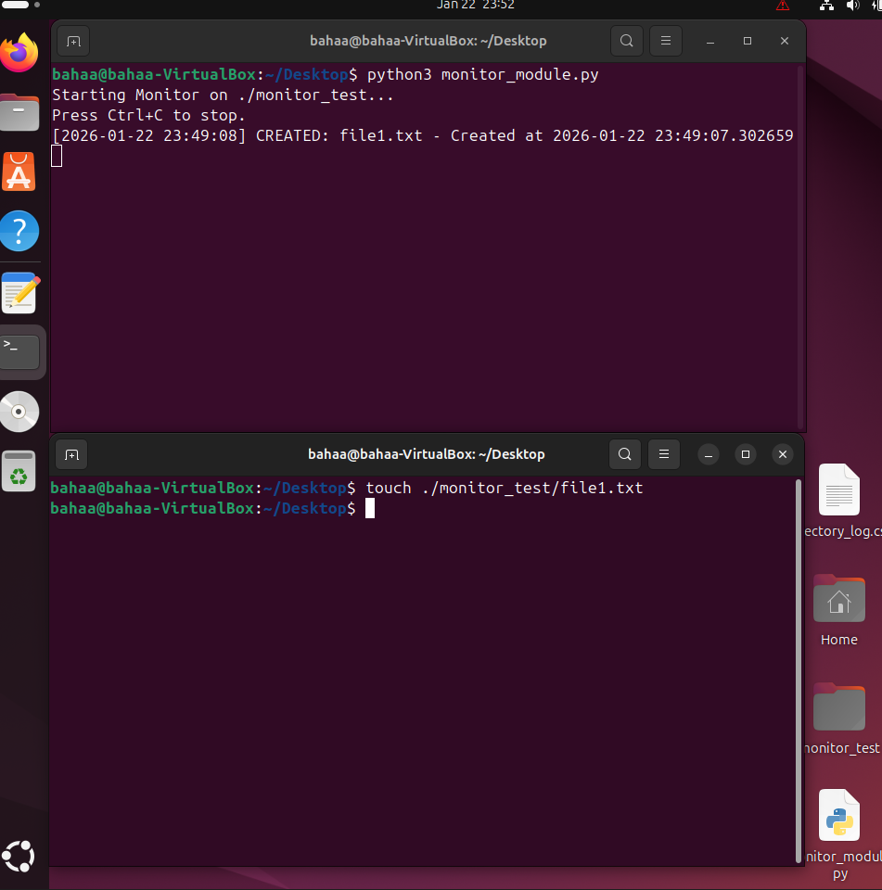

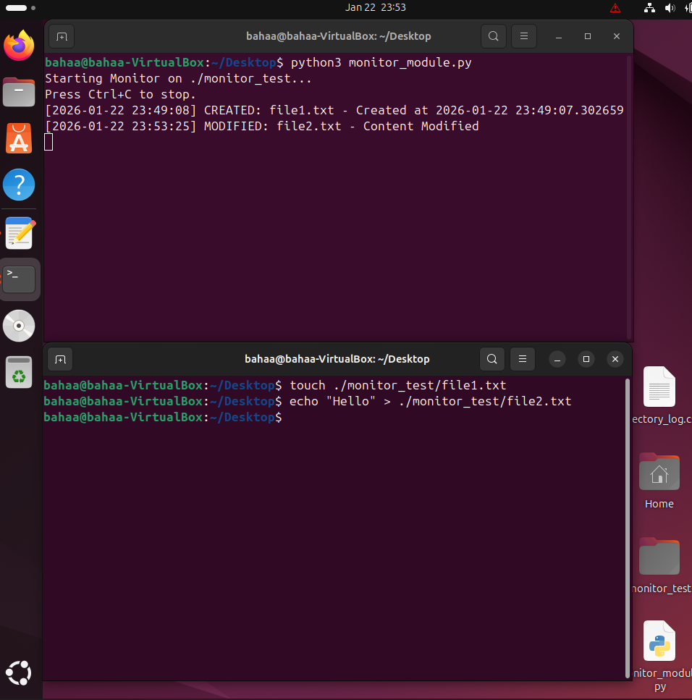

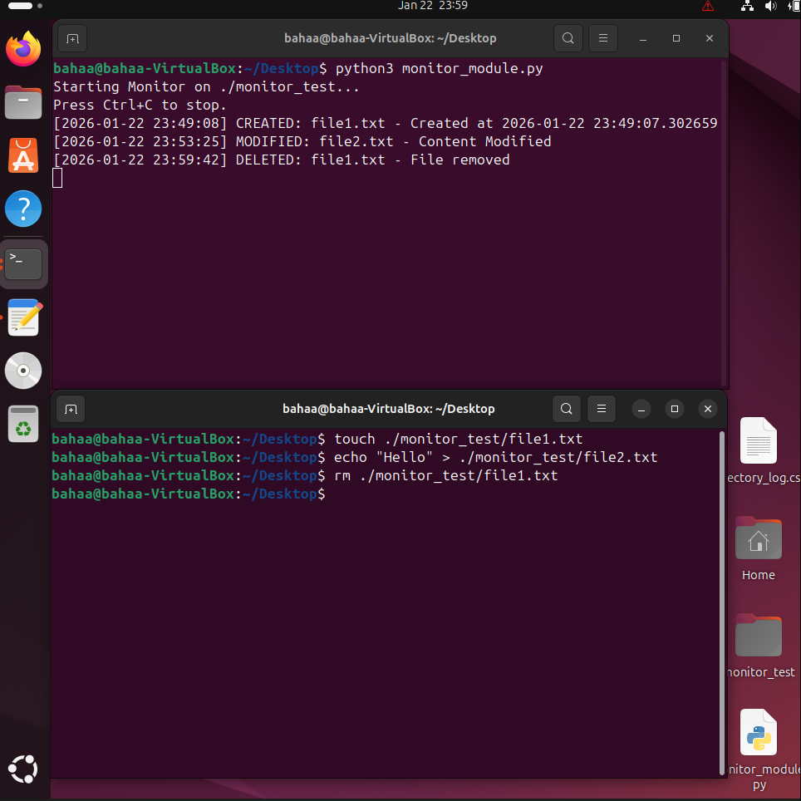

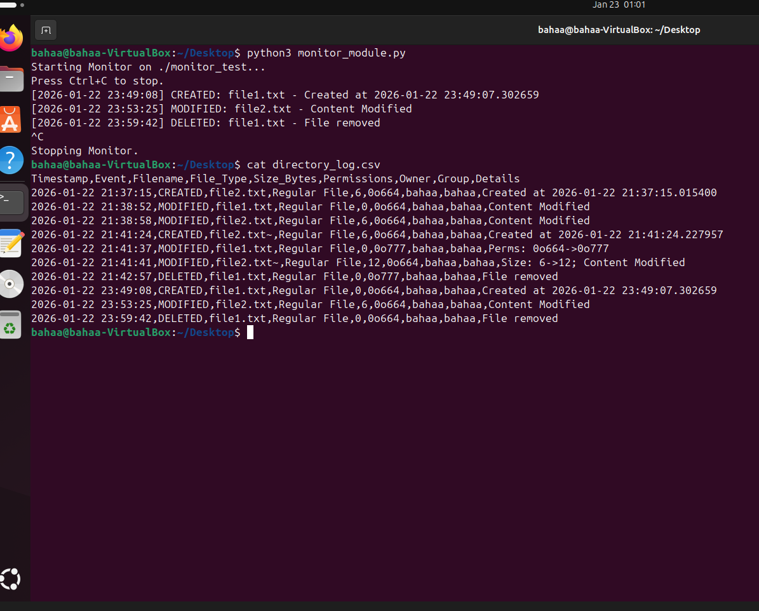
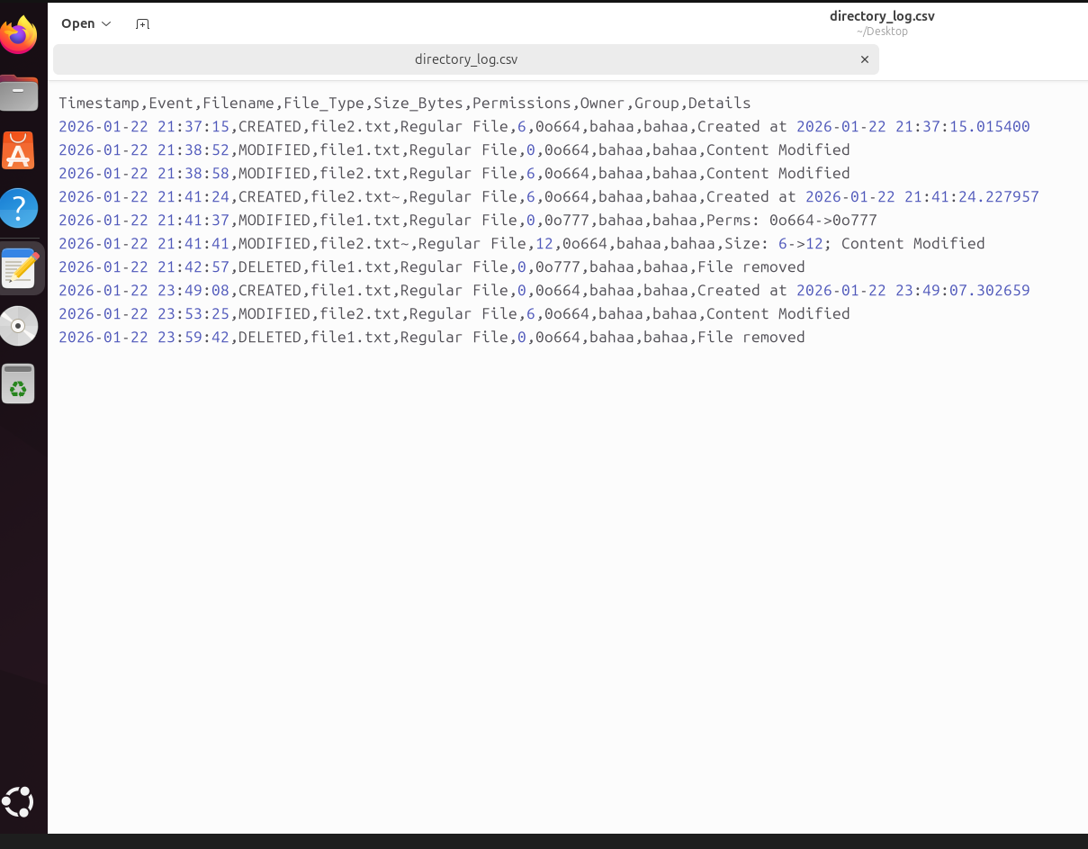

6. Conclusion
The implemented module successfully meets the requirements of tracking directory changes in real-time. It demonstrates a practical application of Linux file system concepts specifically inode metadata inspection and robust Python programming. The resulting CSV log provides accurate data for the subsequent reporting and visualization stages of the group project.

Link to github repository

